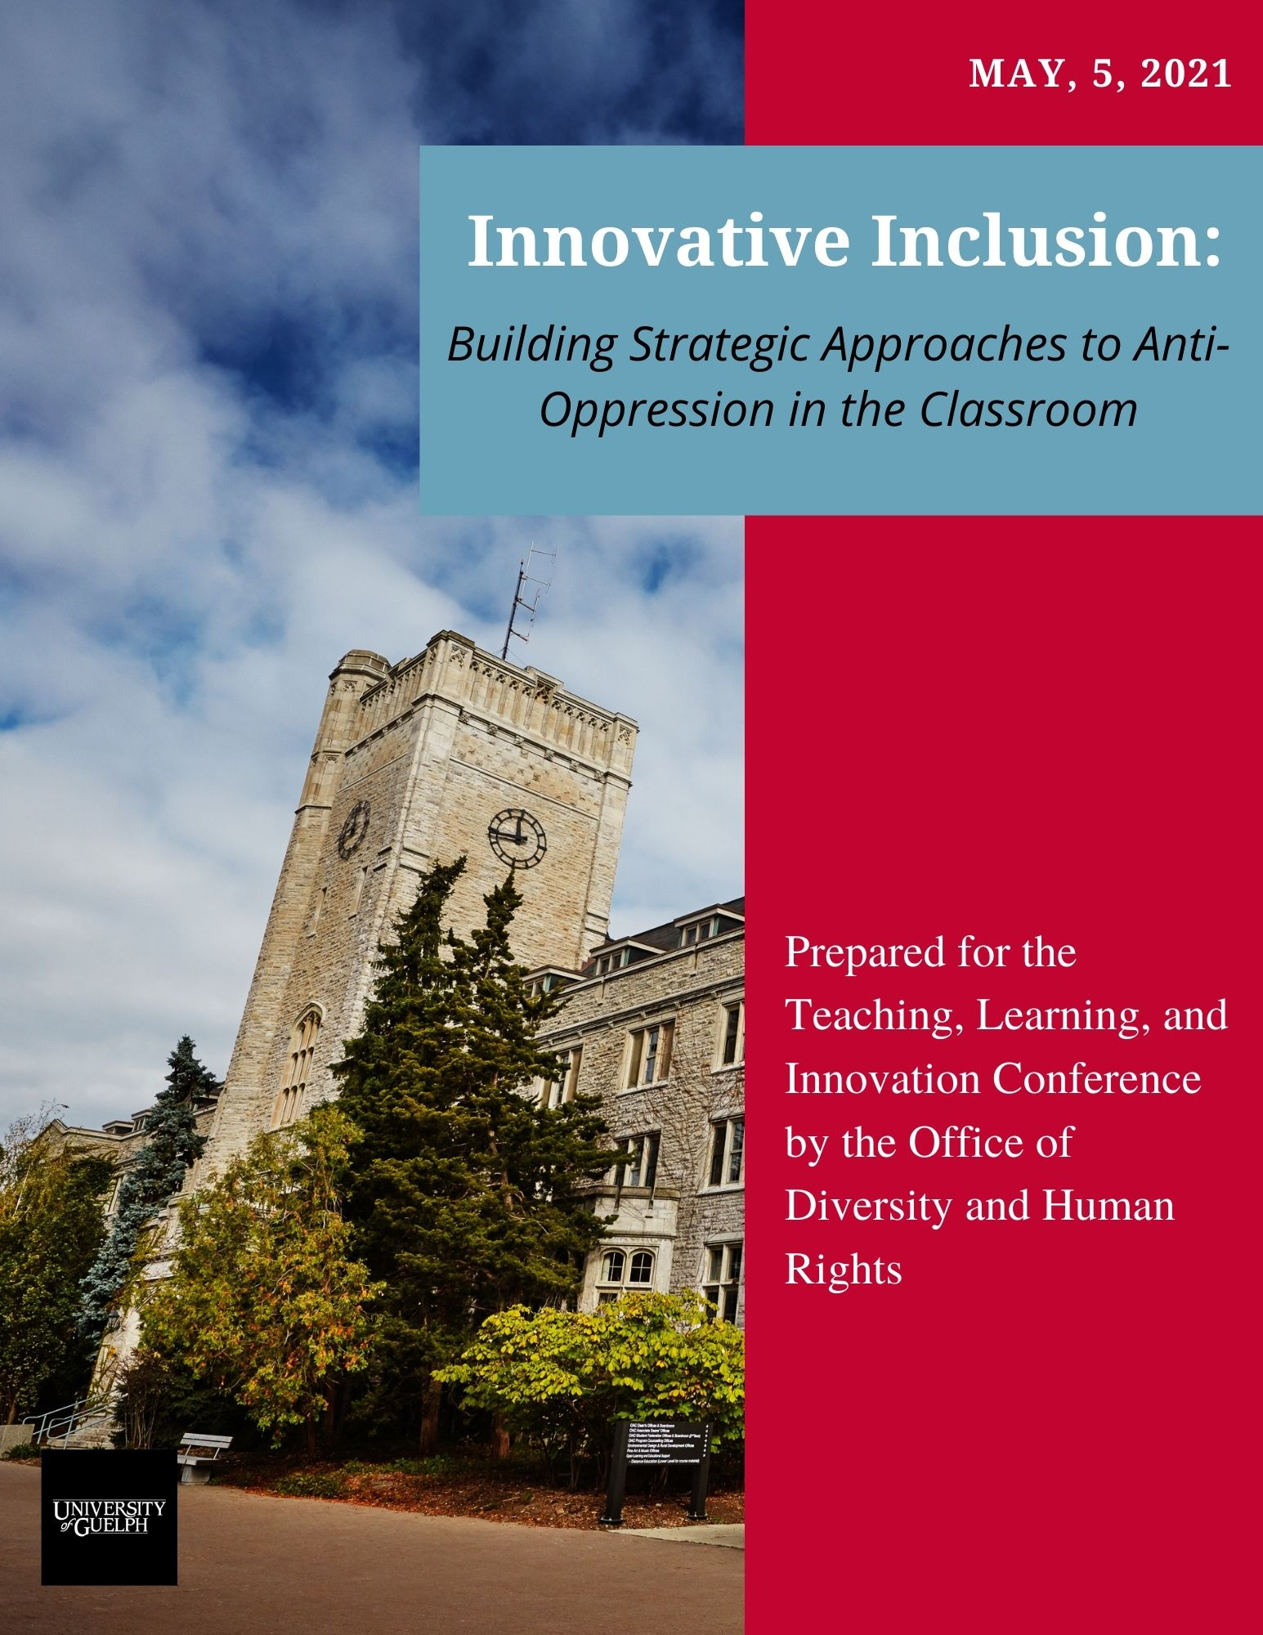

Breakout Session – Innovative Inclusion

Purposes of Today’s Breakout Session

In today’s breakout session, you will:
- Apply your learnings from today’s session on Innovative Inclusion to your own teaching and courses;
- Share perspectives and best practices with other instructors in this breakout session; and
- Develop strategies to take away and implement in your own courses.

Agenda for Today’s Breakout Session

Introduction to Breakout Session Topics (Joseph) | 3:00-3:05
Breakout Session #1 – Complete and Discuss Inclusion Inventory with your breakout team  Joseph will circulate to your breakout room to answer questions | 3:05-3:25
Breakout Session #2 – Choose one of the items on the inclusion inventory and brainstorm ways to implement one of the items that many in the group would like to implement (or would like to improve) in one of their courses.  Joseph will circulate to your breakout room to answer questions | 3:25-3:50
Return to Full Group – Concluding thoughts | 3:50-4:00

Breakout Session #1 – Inclusion Inventory

In your breakout groups, complete the following inclusion inventory and discuss any challenges you have faced in fully implementing these items. You might take some time in your breakout groups to complete the inventory individually before discussing it as a group.
Item | Fully Implemented | Partially Implemented | Not Implemented | Comments
At the start of my courses, I offer a land acknowledgement and connect it to the content of my course.
At the start of my courses, I offer a synopsis of my commitment to equity, diversity, and inclusion and why it matters to me in the classroom.
Item | Fully Implemented | Partially Implemented | Not Implemented | Comments
At the start of my courses, I provide a pre-survey to students to ask them what an inclusive classroom looks like to them and ask them what they need from me to create an inclusive classroom.
At the start of my courses, I invite my students to offer their pronouns (either in person or virtually through a discussion board), and I make note of their pronouns. I also ask students to write down the phonetic pronunciations of their names.
At the start of my courses, I take time to develop inclusion guidelines with my students to foster inclusive discussion. I post these guidelines in an accessible place for students to refer back to during the course of the semester.
I consider the diversity of resources and perspectives being offered to students. My assigned readings and lectures contain material from emerging scholars and scholars from equity-seeking groups.
I ensure that I provide equitable access to mentorship, office hours, reference letters, etc. for students from equity-seeking groups. For example, I do not judge students with accommodations more harshly when considering whether to serve as a referee.
I provide all accommodations as required by law and consider whether it is possible for me to accommodate students whose requests may not be technically required by law or policy.
I create an environment where students are comfortable identifying accommodation needs, such that students are often honest and forthright in emails to me. In other words, I do not receive many vague emails about extensions, and students trust that I will treat their concerns with respect.
I ensure the classroom is a place where respectful dialogue occurs. If “debates” occur, I make sure to monitor students’ responses for microaggressions, bias, or prejudice and centre the experiences of equity, seeking students.
I empower students to call each other in when there are oppressive comments or behaviours in the classroom. When necessary, I use my power and authority to call students out for oppressive comments or behaviour.

Item | Fully Implemented | Partially Implemented | Not Implemented | Comments
If I’m implementing a new policy or procedure in my class, I make sure to think about who the policy or procedure might affect. I ask myself whether it will have a disproportionate effect on equity-seeking students.
I ensure students are comfortable coming forward with accommodation requests. When they do come forward, I thank them for doing so and tell them I’ll work with them.
I socialize the classroom to the normalcy of accommodation by speaking about it openly and reminding students that accommodation is about equity, not about special access or special privileges.
I am mindful about describing a course requirement as challenging or difficult, knowing that those words might be interpreted differently by students from equity-seeking groups.
I ensure that students are provided with detailed criteria for assignments, so they have all the information they need to succeed, and I have objective standards by which to assess students’ work.
I have minimized the use of culturally-biased metrics like spelling and grammar or presentation fundamentals like eye contact/tone/etc.
I have implemented grading tools to reduce bias (e.g., nameless submissions).
I ensure that my feedback on assignments is structured through an intervention narrative rather than a control narrative.
E.g., Control narrative (worse) = “I’m giving you these comments so you’ll have feedback on your paper.”
Intervention narrative (better) = ”I’m giving you these comments, because I have high expectations and I know that you can reach them.”
I have implemented anti-oppressive grading strategies, such as:
- Allowing students to count the best of a certain number of assignments.
- Providing students the opportunity to reflect on their performance in the course and contextualize their performance within everything going on in their lives (for example, self-assessment of participation).
- Assigning a certain portion of their grade to the “best” component
Regardless of the discipline, I ensure I make connections between the subject matter to anti-oppression or social justice. In other words, I provide students with the tools they need to use what they learn to advance anti-oppression, social change, and/or social justice.
If I have community-engaged or experiential learning opportunities in my course, I:
- Ask whether the work/research/learning is helping the communities I intend to serve
- Consider the biases that might be affecting my work

Breakout Session #2 – Brainstorm Ways To Better Implement One/Some/A Few of the Above Items
In your breakout groups, choose one or more of the items above and discuss how to implement them in your course (or how to improve their implementation). Consider choosing one that your group collectively wants to work on. Work through the questions below to generate strategies for successful implementation.

1) Which item do we want to implement/want to do a better job of implementing?
Ex. I want to craft a better EDI statement for my first lecture.

2) What steps should I take to implement this item?
Ex. In order to craft a better EDI statement, I will need to consider _______, I will need to consult with ______, and I need to connect with _______ group(s) on campus.

3) What might I include in this item?
Ex. In my EDI statement in my first lecture, I want to include the following value statements: ____. I will tell students that EDI matters to me, because _______. I will tell students they can get in touch with me to express concerns about EDI by ______.

4) What barriers might I need to overcome to implement this action effectively?

5) How will I know it has been successful? How will I measure its success?

